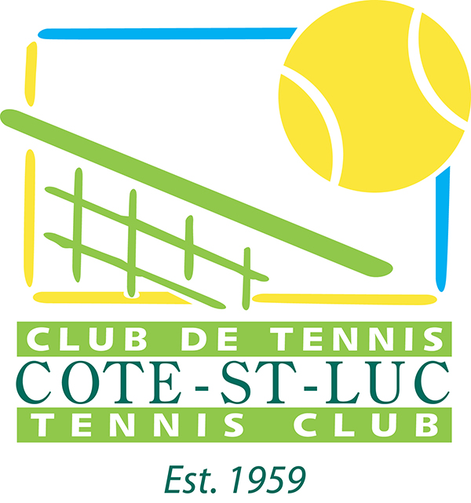

Côte St-Luc Tennis Club
8215 Guelph Blvd
Côte St-Luc, Qc., H4V 2Z3
514-487-7862
csljuniors@gmail.com

We are pleased to announce that the Côte St-Luc Tennis Club is offering juniors the opportunity to participate in the 3rd Côte St-Luc Junior Tournament (2015). There will be singles competitions: 10 and under, 12 and under, and 14 and under, which will take place on clay courts at the Côte St-Luc Tennis Club, 8215 Guelph Blvd, Cote Saint-Luc, Qc., H4V 2Z3.

Matches will take place:
Wednesday, August 12, 2015, 1:00 PM-8:00 PM (Round of 4 & Quarter Final matches),
Thursday, August 13, 2015, 1:00 PM-8:00 PM (Quarter, Semi Finals, Consolation Matches)
Friday August 14, 2015. 1:00 PM - 8:00 PM (Semi Finals, Consolation Matches)
Saturday August 15, 2015. 11:00 AM, 1:00 PM and 3:00 PM (Finals)
Sunday, August 16, 2015 11:00 AM, 1:00 PM and 3:00 PM are reserved for consolation rain, or otherwise delayed games (at the Director’s discretion, conditions permitting).

Participants must wear clay court shoes (no grooved shoes) and suitable tennis attire (Plain T Shirts or Tennis Shirts, Tennis Shorts), (no tank tops or shirts with large graphics or print), without which players will not be permitted on the courts.

The Tournament Director is Norman Fisher. More information may be obtained at the Côte St-Luc Tennis Club, 514-487-7862, or from the Tournament Director, Norman Fisher, by Email normanfisher@sympatico.ca, or phone 514-489-0078 (h) 514-994-3222 (c).

Deadline for registration is Friday August 7, 2015, 7:00 PM. Registrations after that date will be accepted space permitting. Every effort will be made to accommodate all who want to play. Play is limited to 32 particpants. If more than 32 apply, the late filers will be on a waiting list, and may be allowed to play in the consolation matches for a reduced fee, conditions permitting.

The cost is $20.00 which must be submitted in cash (exact bills) prior to the players first match, Wednesday, August 12, 2015, 3:00 PM. A player is not considered registered until the registration form is completed and the payment is made. The registration form may be e-mailed to normanfisher@sympatico.ca or by going to the Côte St-Luc Tennis Club , 8215 Guelph, Cote Saint-Luc, Qc., H4V 2Z3, at which time payment may also be made.

We need to know if a participant is ranked provincially, if the player has participated in other tournaments, or if the player has had a season or more of lessons. We have in the past accepted the advice of teaching pros to schedule matches of for participants of equal ability.

Winners and runners up will receive trophies the week following the tournament at an award ceremony. There may be press coverage and photos will be taken. All players are guaranteed 2 matches. The Director reserves the right to alter the format of play depending on the number of the participants, and a special format may be used for the 10 and under particpants. Players and parents are expected to display good sportsmanship. Players will be advised of rules as required.

Thank you in advance and good luck to all players.

Norman Fisher,
514-489-0078 (h)
514-994-3222 (c)
normanfisher@sympatico.ca

Tournament Director
Côte St-Luc Tennis Club
mailto:csljuniors@gmail.com

Casimir Terynyck
Head pro
Côte St-Luc Tennis Club
514-487-7862
mailto:csljuniors@gmail.com

To PLAY is GOOD
To COMPETE is BETTER.
To ENJOY and LEARN from the experience is BEST.

